Launch httpd container and display the output.

- Install docker and start docker

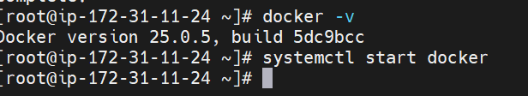

- Pull httpd image
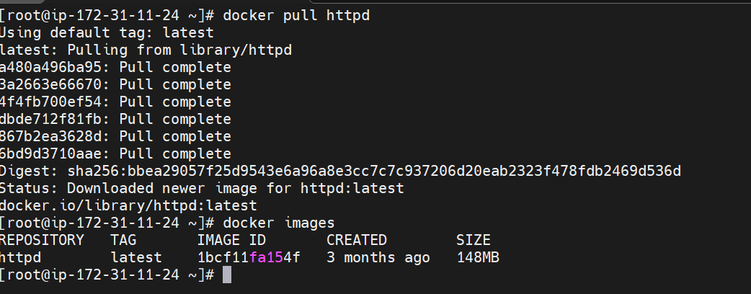
- Run the container as well as do port binding (docker run -itdp 80:80 httpd) -p for port binding
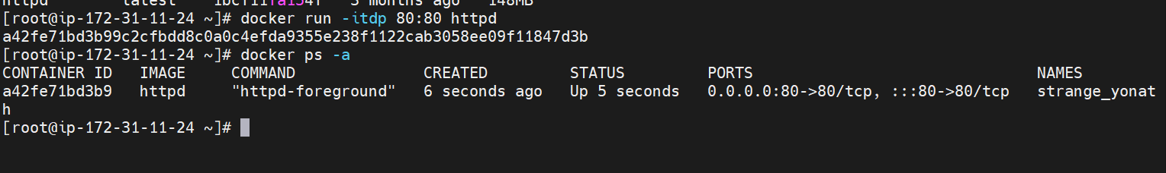

- Edit index.html file {docker exec -it conainers id/name bash}
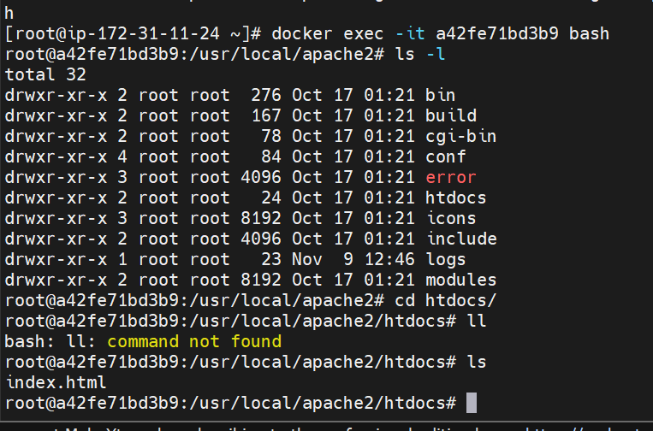

Then edit index.html file
5.Check security group & add 80 port in the security group.
6. hit private ip address (http://43.204.142.173:80)

